Adam Baha 312023704026

Task 1: Redirection and Pipe
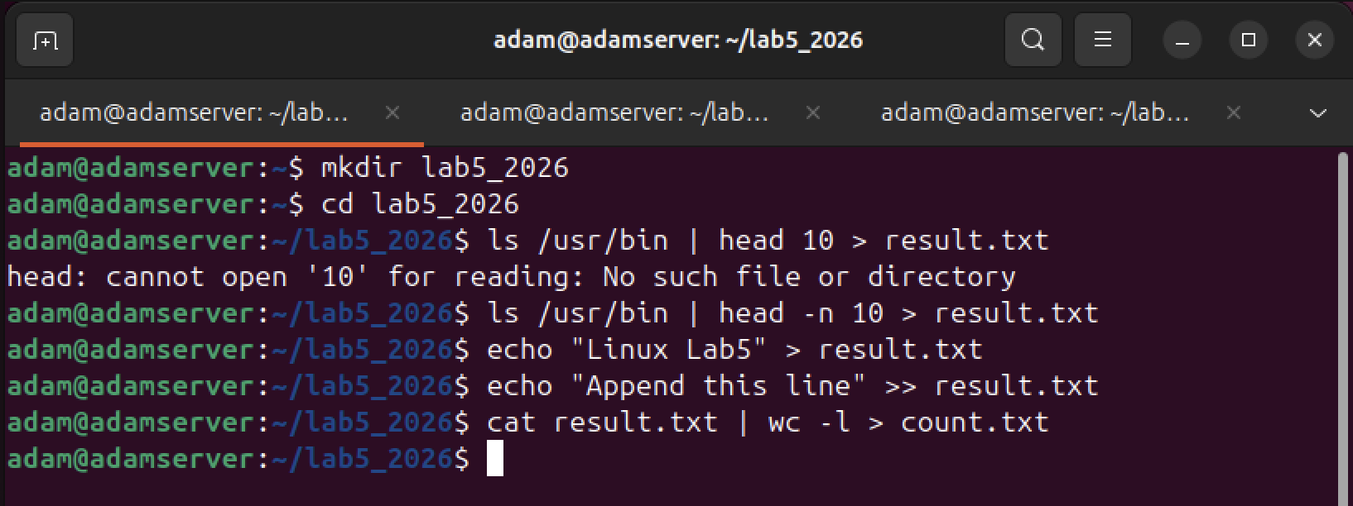

Command Explanations

- ls /usr/bin | head -n 10 > result.txt: Lists files in /usr/bin, pipes the first 10 to head, and uses > to create/overwrite result.txt with these 10 lines.
- echo "Linux Lab5" > result.txt: Uses > to overwrite the entire content of result.txt with the string "Linux Lab5". The previous 10 lines are deleted.
- echo "Append this line" >> result.txt: Uses >> to append the string to the end of the existing file.
- cat result.txt | wc -l > count.txt: Reads the file, pipes it to wc -l to count lines, and saves the result (2) into count.txt.
Why the final file content looks this way: The final result.txt contains exactly two lines because the second command wiped the initial file list, and the third command added one additional line.

Task 2: Wildcards

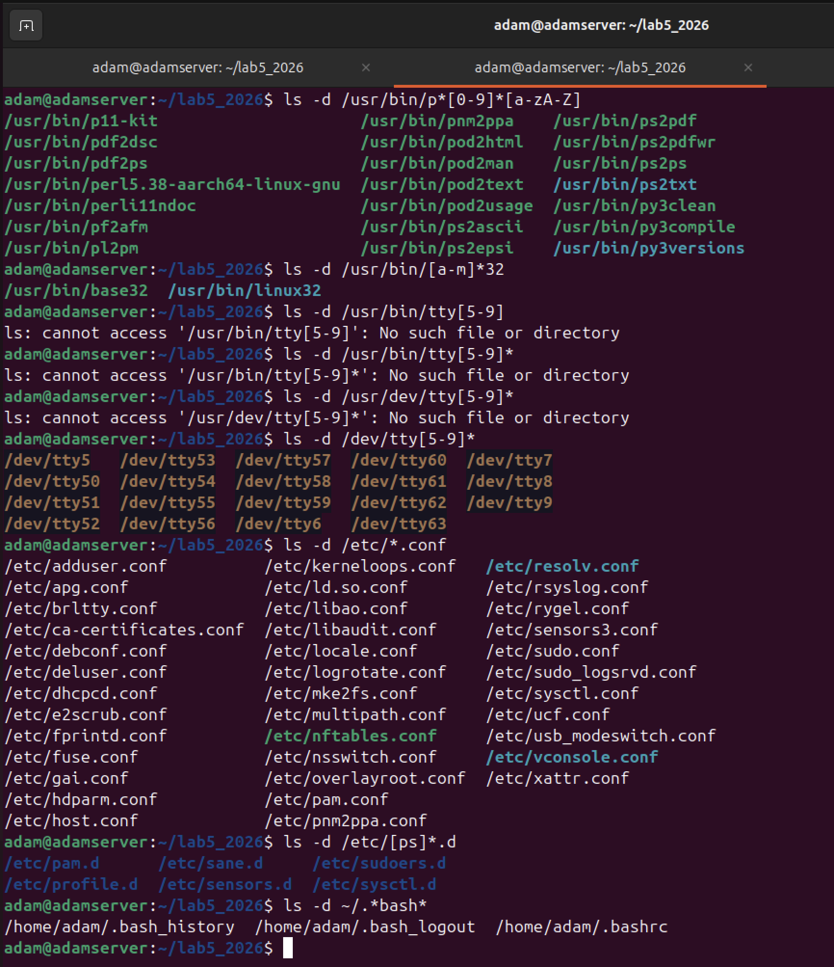

Applied Commands and Logic
Task | Command Used | Wildcard Logic
1 | ls -d /usr/bin/p*[0-9]*[a-zA-Z] | p* starts with p; [0-9]* matches a digit; [a-zA-Z] matches a final letter.
2 | ls -d /usr/bin/[a-m]*32 | [a-m] matches initial letters a through m; *32 ensures it ends in 32.
3 | ls -d /dev/tty[5-9]* | tty[5-9] matches tty5-tty9. The * was added to include multi-digit ttys starting with 5-9.
4 | ls -d /etc/*.conf | *.conf matches any filename ending in the .conf extension.
5 | ls -d /etc/[ps]*.d | [ps] matches either 'p' or 's' at the start; *.d matches the .d suffix.
6 | ls -d ~/.*bash* | . matches hidden files; *bash* matches any file containing the string "bash".

Task 3: Quotation Marks
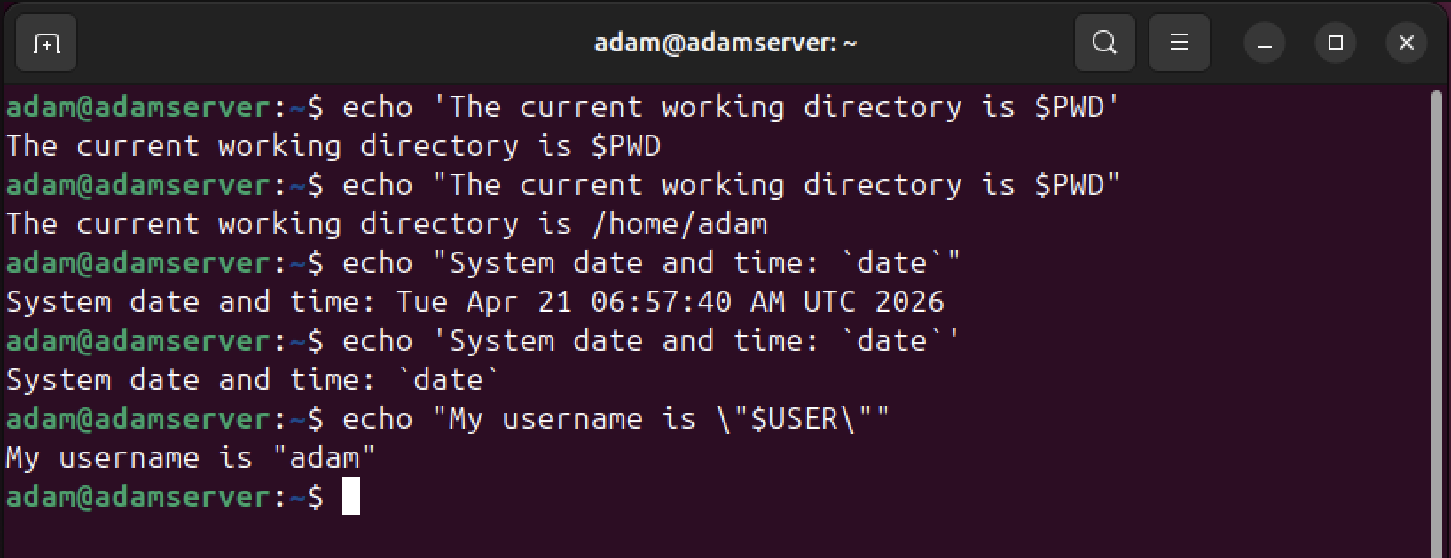

Explanation of Outputs

- Single Quotes (' '): Displays $PWD literally. Single quotes suppress all variable expansion.
- Double Quotes (" "): Displays /home/adam. Double quotes allow the shell to expand the $PWD variable into the actual path.
- Backticks in Double Quotes: Executes the date command and prints the current system time.
- Backticks in Single Quotes: Displays `date` literally. Single quotes prevent the execution of the command inside backticks.
- Escaped Quotes (\"): Prints literal double quotes around the username. The \ prevents the shell from interpreting the inner " as the end of the string.

